Chapter 1:- Introduction to UNIX & LINUX

An operating system (OS) is a resource manager. It takes the form of a set of software routines that allow users and application programs to access system resources (e.g. the CPU, memory, disks, modems, printers network cards etc.) in a safe, efficient and abstract way.
For example, an OS ensures safe access to a printer by allowing only one application program to send data directly to the printer at any one time. An OS encourages efficient use of the CPU by suspending programs that are waiting for I/O operations to complete to make way for programs that can use the CPU more productively. An OS also provides convenient abstractions (such as files rather than disk locations) which isolate application programmers and users from the details of the underlying hardware.
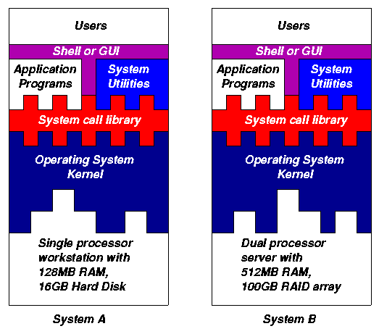
Fig. 1.1: General operating system architecture
Fig. 1.1 presents the architecture of a typical operating system and shows how an OS succeeds in presenting users and application programs with a uniform interface without regard to the details of the underlying hardware. We see that:
- The operating system kernel is in direct control of the underlying hardware. The kernel provides low-level device, memory and processor management functions (e.g. dealing with interrupts from hardware devices, sharing the processor among multiple programs, allocating memory for programs etc.)
- Basic hardware-independent kernel services are exposed to higher-level programs through a library of system calls (e.g. services to create a file, begin execution of a program, or open a logical network connection to another computer).
- Application programs (e.g. word processors, spreadsheets) and system utility programs (simple but useful application programs that come with the operating system, e.g. programs which find text inside a group of files) make use of system calls. Applications and system utilities are launched using a shell (a textual command line interface) or a graphical user interface that provides direct user interaction.
Operating systems (and different flavours of the same operating system) can be distinguished from one another by the system calls, system utilities and user interface they provide, as well as by the resource scheduling policies implemented by the kernel.

1.3 A Brief History of UNIX

UNIX has been a popular OS for more than two decades because of its multi-user, multi-tasking environment, stability, portability and powerful networking capabilities. What follows here is a simplified history of how UNIX has developed (to get an idea for how complicated things really are, see the web site http://www.levenez.com/unix/).
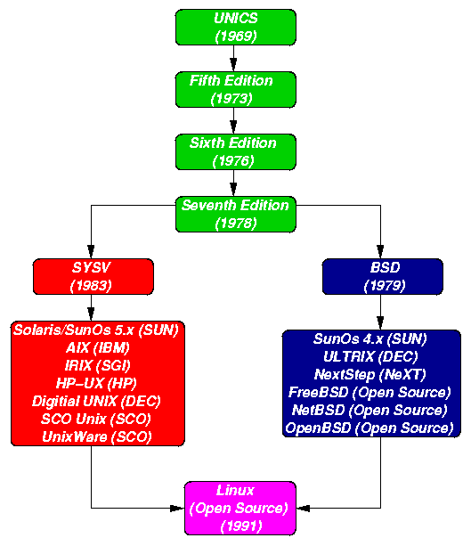
Fig. 1.2: Simplified UNIX FamilyTree
In the late 1960s, researchers from General Electric, MIT and Bell Labs launched a joint project to develop an ambitious multi-user, multi-tasking OS for mainframe computers known as MULTICS (Multiplexed Information and Computing System). MULTICS failed (for some MULTICS enthusiasts "failed" is perhaps too strong a word to use here), but it did inspire Ken Thompson, who was a researcher at Bell Labs, to have a go at writing a simpler operating system himself. He wrote a simpler version of MULTICS on a PDP7 in assembler and called his attempt UNICS (Uniplexed Information and Computing System). Because memory and CPU power were at a premium in those days, UNICS (eventually shortened to UNIX) used short commands to minimize the space needed to store them and the time needed to decode them - hence the tradition of short UNIX commands we use today, e.g. ls, cp, rm, mv etc.
Ken Thompson then teamed up with Dennis Ritchie, the author of the first C compiler in 1973. They rewrote the UNIX kernel in C - this was a big step forwards in terms of the system's portability - and released the Fifth Edition of UNIX to universities in 1974. The Seventh Edition, released in 1978, marked a split in UNIX development into two main branches: SYSV (System 5) and BSD (Berkeley Software Distribution). BSD arose from the University of California at Berkeley where Ken Thompson spent a sabbatical year. Its development was continued by students at Berkeley and other research institutions. SYSV was developed by AT&T and other commercial companies. UNIX flavours based on SYSV have traditionally been more conservative, but better supported than BSD-based flavours.
The latest incarnations of SYSV (SVR4 or System 5 Release 4) and BSD Unix are actually very similar. Some minor differences are to be found in file system structure, system utility names and options and system call libraries as shown in Fig 1.3.
Feature Typical SYSV Typical BSD
kernel name /unix /vmunix
boot init /etc/rc.d directories /etc/rc.* files
mounted FS /etc/mnttab /etc/mtab
default shell sh, ksh csh, tcsh
FS block size 512 bytes->2K 4K->8K
print subsystem lp, lpstat, cancel lpr, lpq, lprm
echo command echo "\c" echo -n
(no new line)
ps command ps -fae ps -aux
multiple wait poll select
syscalls
memory access memset, memcpy bzero, bcopy
syscalls
Fig. 1.3: Differences between SYSV and BSD
Linux is a free open source UNIX OS for PCs that was originally developed in 1991 by Linus Torvalds, a Finnish undergraduate student. Linux is neither pure SYSV or pure BSD. Instead, incorporates some features from each (e.g. SYSV-style startup files but BSD-style file system layout) and aims to conform with a set of IEEE standards called POSIX (Portable Operating System Interface). To maximise code portability, it typically supports SYSV, BSD and POSIX system calls (e.g. poll, select, memset, memcpy, bzero and bcopy are all supported).
The open source nature of Linux means that the source code for the Linux kernel is freely available so that anyone can add features and correct deficiencies. This approach has been very successful and what started as one person's project has now turned into a collaboration of hundreds of volunteer developers from around the globe. The open source approach has not just successfully been applied to kernel code, but also to application programs for Linux (see e.g. http://www.freshmeat.net).
As Linux has become more popular, several different development streams or distributions have emerged, e.g. Redhat, Slackware, Mandrake, Debian, and Caldera. A distribution comprises a prepackaged kernel, system utilities, GUI interfaces and application programs.
Redhat is the most popular distribution because it has been ported to a large number of hardware platforms (including Intel, Alpha, and SPARC), it is easy to use and install and it comes with a comprehensive set of utilities and applications including the X Windows graphics system, GNOME and KDE GUI environments, and the StarOffice suite (an open source MS-Office clone for Linux).

1.4 Architecture of the Linux Operating System

Linux has all of the components of a typical OS (at this point you might like to refer back to Fig 1.1):
- Kernel
The Linux kernel includes device driver support for a large number of PC hardware devices (graphics cards, network cards, hard disks etc.), advanced processor and memory management features, and support for many different types of filesystems (including DOS floppies and the ISO9660 standard for CDROMs). In terms of the services that it provides to application programs and system utilities, the kernel implements most BSD and SYSV system calls, as well as the system calls described in the POSIX.1 specification.
The kernel (in raw binary form that is loaded directly into memory at system startup time) is typically found in the file /boot/vmlinuz, while the source files can usually be found in /usr/src/linux.The latest version of the Linux kernel sources can be downloaded from http://www.kernel.org.
- Shells and GUIs
Linux supports two forms of command input: through textual command line shells similar to those found on most UNIX systems (e.g. sh - the Bourne shell, bash - the Bourne again shell and csh - the C shell) and through graphical interfaces (GUIs) such as the KDE and GNOME window managers. If you are connecting remotely to a server your access will typically be through a command line shell.
- System Utilities
Virtually every system utility that you would expect to find on standard implementations of UNIX (including every system utility described in the POSIX.2 specification) has been ported to Linux. This includes commands such as ls, cp, grep, awk, sed, bc, wc, more, and so on. These system utilities are designed to be powerful tools that do a single task extremely well (e.g. grep finds text inside files while wc counts the number of words, lines and bytes inside a file). Users can often solve problems by interconnecting these tools instead of writing a large monolithic application program.
Like other UNIX flavours, Linux's system utilities also include server programs called daemons which provide remote network and administration services (e.g. telnetd and sshd provide remote login facilities, lpd provides printing services, httpd serves web pages, crond runs regular system administration tasks automatically). A daemon (probably derived from the Latin word which refers to a beneficient spirit who watches over someone, or perhaps short for "Disk And Execution MONitor") is usually spawned automatically at system startup and spends most of its time lying dormant (lurking?) waiting for some event to occur.
- Application programs
Linux distributions typically come with several useful application programs as standard. Examples include the emacs editor, xv (an image viewer), gcc (a C compiler), g++ (a C++ compiler), xfig (a drawing package), latex (a powerful typesetting language) and soffice (StarOffice, which is an MS-Office style clone that can read and write Word, Excel and PowerPoint files).
Redhat Linux also comes with rpm, the Redhat Package Manager which makes it easy to install and uninstall application programs.

Difference between CentOS, Fedora, and RHEL
The biggest open source company is nowadays Red Hat. It is known for its contributions to many open source projects, including the Linux kernel itself. Less known is that Red Hat is involved in different Linux distributions, directly or indirectly.
Fedora
Fedora has received many updates and individual releases over the years. It is a playground for new functionality. Often new technology is found here. It can be compared with other distributions like Arch Linux, except that it is slightly less aggressive in deploying the latest software components for everything.
- Community driven
- Short release cycles (6 months)
- Focus on features and new technology
- Common on desktop
The difference between Fedora and other distributions is the corporate support by Red Hat. That means that professional developers can work on projects that are first tested in Fedora. A lot of these components may then also be picked up by other distributions. It also feeds the RHEL product. Everything that is considered to be stable and useful for demanding enterprises, might be moved in phases towards the RHEL distribution.
Red Hat Enterprise Linux (RHEL)
The Enterprise product of Red Hat is named RHEL for short. The main difference with Fedora is that is focused on companies which prefer stability. The most business-critical services are deployed on this platform. Battle-tested components might finally end up in this distribution.
- Focus on stability
- Supported by Red Hat
- Paid license
- Common on server
For companies relying on the stability of a Linux distribution, might want to go for this distribution. It is also common to see a split: some systems runs RHEL, less business-critical systems run CentOS.
CentOS
CentOS is a spinoff of RHEL. It is based on the same code base. It has recompiled all the source packages in it, making it effectively a very similar system. CentOS is great if you like the stability of RHEL and want to reduce your costs.
- Based on RHEL
- Community driven
- Focus on stability
- Free
This option might be less suitable for business-critical services as it isn’t officially supported by Red Hat. Also if you prefer recent software packages, CentOS (like RHEL) might not always be the best option.

Important Linux Commands
This section gives insight into the most important commands of your SuSE Linux system. Along with the individual commands, parameters are listed and, where appropriate, a typical sample application is introduced. To learn more about the various commands, it is usually possible to get additional information with the man program followed by the name of the command, for example, man ls.
In these manual pages, move up and down with PgUp and PgDn and move between the beginning and the end of a document with Home and End. End this viewing mode by pressing Q. Learn more about the man command itself with man.
There are many more commands than listed in this chapter. For information about other commands or more detailed information, we recommend the O'Reilly publication Linux in a Nutshell. In the following overview, the individual command elements are written in different typefaces.
- The actual command is always printed as command. Without this, nothing can function.
- Options without which the respective program cannot function are printed in italics.
- Further details, like file names, which must be passed to a command for correct functioning, are written in the Courier font.
- Specifications or parameters that are not required are placed in [brackets].
Adjust possible specifications to your needs. It makes no sense to write ls file(s), if no file named file(s) actually exists. You can usually combine several parameters, for example, by writing ls -la instead of ls -l -a.

File Commands

File Administration
ls [option(s)] [file(s)]
If you run ls without any additional parameters, the program will list the contents of the current directory in short form.
-l
detailed list
-a
displays hidden files
cp [option(s)] sourcefile targetfile
Copies sourcefile to targetfile.
-i
Waits for confirmation, if necessary, before an existing targetfile is overwritten
-r
Copies recursively (includes subdirectories)
mv [option(s)] sourcefile targetfile
Copies sourcefile to targetfile then deletes the original sourcefile.
-b
Creates a backup copy of the sourcefile before moving
-i
Waits for confirmation, if necessary, before an existing targetfile is overwritten
rm [option(s)] file(s)
Removes the specified files from the file system. Directories are not removed by rm unless the option -r is used.
-r
Deletes any existing subdirectories
-i
Waits for confirmation before deleting each file.
ln [option(s)] sourcefile targetfile
Creates an internal link from the sourcefile to the targetfile, under a different name. Normally, such a link points directly to the sourcefile on one and the same file system. However, if ln is executed with the -s option, it creates a symbolic link that only points to the directory where the sourcefile is located, thus enabling linking across file systems.
-s
Creates a symbolic link
cd [options(s)] [directory]
Changes the current directory. cd without any parameters changes to the user's home directory.
mkdir [option(s)] directoryname
Creates a new directory.
rmdir [option(s)] directoryname
Deletes the specified directory, provided it is already empty.
chown [option(s)] username.group file(s)
Transfers the ownership of a file to the user with the specified user name.
-R
Changes files and directories in all subdirectories.
chgrp [option(s)] groupname file(s)
Transfers the group ownership of a given file to the group with the specified group name. The file owner can only change group ownership if a member of both the existing and the new group.
chmod [options] mode file(s)
Changes the access permissions.
The mode parameter has three parts: group, access, and access type. group accepts the following characters:
u
user
g
group
o
others
For access, access is granted by the + symbol and denied by the - symbol.
The access type is controlled by the following options:
r
read
w
write
x
eXecute — executing files or changing to the directory.
s
Set uid bit — the application or program is started as if it were started by the owner of the file.
gzip [parameters] file(s)
This program compresses the contents of files, using complex mathematical algorithms. Files compressed in this way are given the extension .gz and need to be uncompressed before they can be used. To compress several files or even entire directories, use the tar command.
-d
decompresses the packed gzip files so they return to their original size and can be processed normally (like the command gunzip).
tar options archive file(s)
The tar puts one file or (usually) several files into an archive. Compression is optional.
tar is a quite complex command with a number of options available. The most frequently used options are:
-f
Writes the output to a file and not to the screen as is usually the case
-c
Creates a new tar archive
-r
Adds files to an existing archive
-t
Outputs the contents of an archive
-u
Adds files, but only if they are newer than the files already contained in the archive
-x
Unpacks files from an archive (extraction)
-z
Packs the resulting archive with gzip
-j
Compresses the resulting archive with bzip2
-v
Lists files processed
The archive files created by tar end with .tar. If the tar archive was also compressed using gzip, the ending is .tgz or .tar.gz. If it was compressed using bzip2, .tar.bz2.
Application examples can be found in Section “Archives and Data Compression”.
locate pattern(s)
The locate command can find in which directory a specified file is located. If desired, use wild cards to specify file names. The program is very speedy, as it uses a database specifically created for the purpose (rather than searching through the entire file system). This very fact, however, also results in a major drawback: locate is unable to find any files created after the latest update of its database.
The database can be generated by root with updatedb.
updatedb [options(s)]
This command performs an update of the database used by locate. To include files in all existing directories, run the program as root. It also makes sense to place it in the background by appending an ampersand (&), so you can immediately continue working on the same command line (updatedb &).
find [option(s)]
The find command allows you to search for a file in a given directory. The first argument specifies the directory in which to start the search. The option -name must be followed by a search string, which may also include wild cards. Unlike locate, which uses a database, find scans the actual directory.

Commands to Access File Contents
cat [option(s)] file(s)
The cat command displays the contents of a file, printing the entire contents to the screen without interruption.
-n
Numbers the output on the left margin
less [option(s)] file(s)
This command can be used to browse the contents of the specified file. Scroll half a screen page up or down with PgUp and PgDn or a full screen page down with Space. Jump to the beginning or end of a file using Home and End. Press Q to exit the program.
grep [option(s)] searchstring filenames
The grep command finds a specific searchstring in the specified file(s). If the search string is found, the command displays the line in which the searchstring was found along with the file name.
-i
Ignores case
-l
Only displays the names of the respective files, but not the text lines
-n
Additionally displays the numbers of the lines in which it found a hit
-l
Only lists the files in which searchstring does not occur
diff [option(s)] file1 file2
The diff command compares the contents of any two files. The output produced by the program lists all lines that do not match.
This is frequently used by programmers who need only send their program alterations and not the entire source code.
-q
Only reports whether the two given files differ

File Systems
mount [option(s)] [<device>] mountpoint
This command can be used to mount any data media, such as hard disks, CD-ROM drives, and other drives, to a directory of the Linux file system.
-r
mount read-only
-t filesystem
Specifies the file system. The most common are ext2 for Linux hard disks, msdos for MS-DOS media, vfat for the Windows file system, and iso9660 for CDs.
For hard disks not defined in the file /etc/fstab, the device type must also be specified. In this case, only root can mount. If the file system should also be mounted by other users, enter the option user in the appropriate line in the /etc/fstab file (separated by commas) and save this change. Further information is available in mount.
umount [option(s)] mountpoint
This command unmounts a mounted drive from the file system. To prevent data loss, run this command before taking a removable data medium from its drive. Normally, only root is allowed to run the commands mount and umount. To enable other users to run these commands, edit the /etc/fstab file to specify the option user for the respective drive.

System Commands

System Information
df [option(s)] [directory]
The df (disk free) command, when used without any options, displays information about the total disk space, the disk space currently in use, and the free space on all the mounted drives. If a directory is specified, the information is limited to the drive on which that directory is located.
-H
shows the number of occupied blocks in gigabytes, megabytes, or kilobytes — in human-readable format
-t
Type of file system (ext2, nfs, etc.)
du [option(s)] [path]
This command, when executed without any parameters, shows the total disk space occupied by files and subdirectories in the current directory.
-a
Displays the size of each individual file
-h
Output in human-readable form
-s
Displays only the calculated total size
free [option(s)]
The command free displays information about RAM and swap space usage, showing the total and the used amount in both categories.
-b
Output in bytes
-k
Output in kilobytes
-m
Output in megabytes
date [option(s)]
This simple program displays the current system time. If run as root, it can also be used to change the system time. Details about the program are available in date.

Processes
top [options(s)]
top provides a quick overview of the currently running processes. Press H to access a page that briefly explains the main options to customize the program.
ps [option(s)] [process ID]
If run without any options, this command displays a table of all your own programs or processes — those you started. The options for this command are not preceded by hyphen.
aux
Displays a detailed list of all processes, independent of the owner.
kill [option(s)] process ID
Unfortunately, sometimes a program cannot be terminated in the normal way. However, in most cases, you should still be able to stop such a runaway program by executing the kill command, specifying the respective process ID (see top and ps).
kill sends a TERM signal that instructs the program to shut itself down. If this does not help, the following parameter can be used:
-9
Sends a KILL signal instead of a TERM signal, with which the process really is annihilated by the operating system. This brings the specific processes to an end in almost all cases.
killall [option(s)] processname
This command is similar to kill, but uses the process name (instead of the process ID) as an argument, causing all processes with that name to be killed.

Network
ping [option(s)] host name|IP address
The ping command is the standard tool for testing the basic functionality of TCP/IP networks. It sends a small data packet to the destination host, requesting an immediate reply. If this works, ping displays a message to that effect, which indicates that the network link is basically functioning.
-c
number Determines the total number of packages to send and ends after they have been dispatched. By default, there is no limitation set.
-f
flood ping: sends as many data packages as possible. A popular means, reserved to root, to test networks.
-i
value Specifies the interval between two data packages in seconds. Default: one second
nslookup
The Domain Name System resolves domain names to IP addresses. With this tool, send queries to information servers (DNS servers).
telnet [option(s)] host name or IP address
Telnet is actually an Internet protocol that enables you to work on remote hosts across a network. telnet is also the name of a Linux program that uses this protocol to enable operations on remote computers.

Warning
Do not use telnet over a network on which third parties can eavesdrop. Particularly on the Internet, use encrypted transfer methods, such as ssh, to avoid the risk of malicious misuse of a password (see the man page for ssh).

Miscellaneous
passwd [option(s)] [username]
Users may change their own passwords at any time using this command. Furthermore, the administrator root can use the command to change the password of any user on the system.
su [option(s)] [username]
The su command makes it possible to log in under a different user name from a running session. When using the command without specifying a user name, you will be prompted for the root password. Specify a user name and the corresponding password to use the environment of the respective user. The password is not required from root, as root is authorized to assume the identity of any user.
halt [option(s)]
To avoid loss of data, you should always use this program to shut down your system.
reboot [option(s)]
Does the same as halt with the difference that the system performs an immediate reboot.
clear
This command cleans up the visible area of the console. It has no options.

Vi Editor
For example, if you want to edit a text file you can easily use one of the powerful GUI tools like Kate, Kwrite etc., which are all like notepad in Windows though much more powerful; they have features such as multiple file editing and syntax highlighting (if you open an HTML file it understands the HTML tags and highlights them for you). However, you can also use the very powerful vi editor.
When first confronted by vi most users are totally lost, you open a file in vi (e.g vi document1) and try to type, but nothing seems to happen.. the system just keeps beeping!
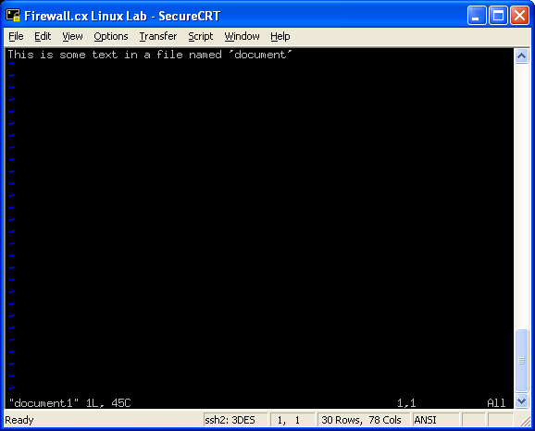
Well that's because vi functions in two modes, one is the command mode, where you can give vi commands such as open a file, exit, split the view, search and replace etc., and the other mode is the insert view where you actually type text!
Don't be put off by the fact that vi doesn't have a pretty GUI interface to go with it, this is an incredibly powerful text editor that would be well worth your time learning... once you're done with it you'll never want to use anything else!
Realising that most people would find vi hard to use straight off, there is a useful little walk-through tutorial that you can access by typing vimtutor at a command line. The tutorial opens vi with the tutorial in it, and you try out each of the commands and shortcuts in vi itself. It's very easy and makes navigating around vi a snap. Check it out.
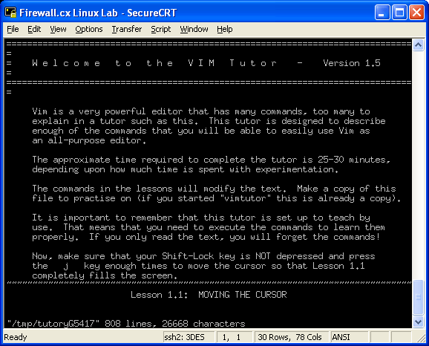

Grep
Another very useful Linux command is the grep command. This little baby searches for a string in any file. The grep command is frequently used in combination with other commands in order to search for a specific string. For example, if we wanted to check our web server's log file for a specific URL query or IP address, the 'grep' command would do this job just fine.
If, on the other hand, you want to find every occurence of 'hello world' in every .txt file you have, you would type grep "hello world" *.txt
You'll see some very common command structures later on that utilise 'grep'. At the same time, you can go ahead and check grep's man page by typing man grep , it has a whole lot of very powerful options.
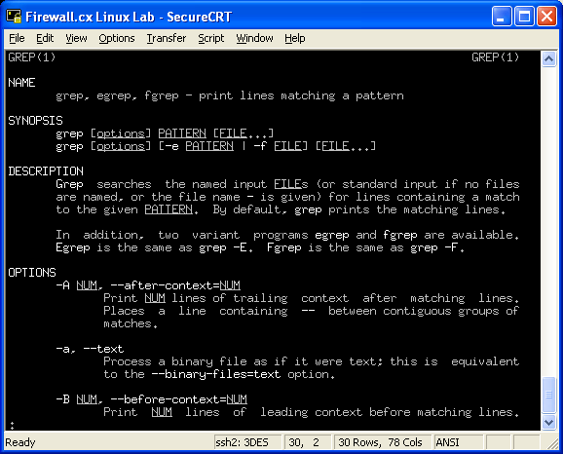



PS - Process ID (PID) display
The ps command will show all the tasks you are currently running on the system, it's the equivalent of Windows Task Manager and you'll be happy to know that there are also GUI versions of 'ps'.
If you're logged in as root in your Linux system and type ps -aux , you'll see all processes running on the system by every user, however, for security purposes, users will only be able to see processes owned by them when typing the same command.
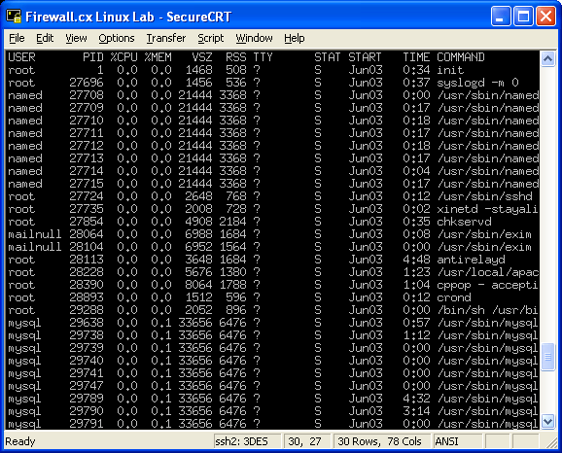
Again, man ps will provide you with a bundle of options available by the command.

Kill
The 'kill' command is complementary to the 'ps' command as it will allow you to terminate a process revealed with the previous command. In cases where a process is not responding, you would use the following syntax to effectively kill it: kill -9 pid where 'pid' is the Process ID (PID) that 'ps' displays for each task.

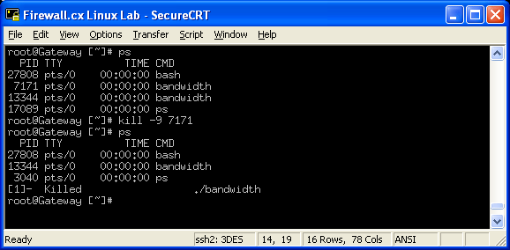
In the above example, we ran a utility called 'bandwidth' twice which is shown as two different process IDs (7171 & 13344) using the ps command. We then attempted to kill one of them using the command kill -9 7171 . The next time we ran the 'ps', the system reported that a process that was started with the './bandwidth' command had been previously killed.
Another useful flag we can use with the 'kill' command is the -HUP. This neat flag won't kill the process but pause it and at the same time force it to reload its configuration. So, if you've got a service running and need to restart it because of changes made in its configuration file, then the -HUP flag will do just fine. Many people look at it as an alternative 'reload' command.
The complete syntax to make use of the flag is: kill -HUP pid where 'pid' is the process ID number you can obtain using the 'ps' command, just as we saw in the previous examples.

Chaining Commands, Redirecting Output, Piping
In Linux, you can chain groups of commands together with incredible ease, this is where the true power of the Linux command line exists, you use small tools, each of which does one little task and passes the output on to the next one.
For example, when you run the ps aux command, you might see a whole lot of output that you cannot read in one screen, so you can use the pipe symbol ( | ) to send the output of 'ps' to 'grep' which will search for a string in that output. This is known as 'piping' as it's similar to plumbing where you use a pipe to connect two things together.

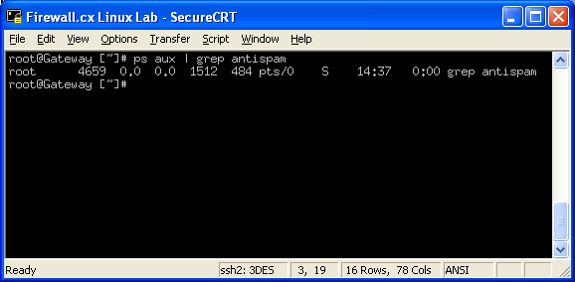
Say you want to find the task 'antispam' : you can run ps aux | grep antispam . Ps 'pipes' its output to grep and it then searches for the string, showing you only the line with that text.
If you wanted ps to display one page at a time you can pipe the output of ps to either more or less . The advantage of less is that it allows you to scroll upwards as well. Try this: ps aux | less . Now you can use the cursors to scroll through the output, or use pageup, pagedown.

Alias
The 'alias' command is very neat, it lets you make a shortcut keyword for another longer command. Say you don't always want to type ps aux | less, you can create an alias for it.. we'll call our alias command 'pl'. So you type alias pl='ps aux | less' .
Now whenever you type pl , it will actually run ps aux | less - Neat, is'nt it?

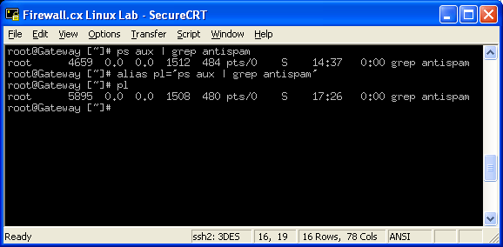

You can view the aliases that are currently set by typing alias:

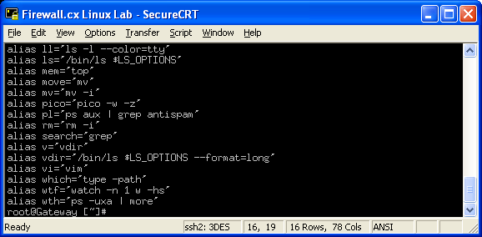
As you can see, there are quite a few aliases already listed for the 'root' account we are using. You'll be suprised to know that most Linux distributions automatically create a number of aliases by default - these are there to make your life as easy as possible and can be deleted anytime you wish.

Output Redirection
It's not uncommon to want to redirect the output of a command to a text file for further processing. In the good old DOS operating system, this was achieved by using the '>' operator. Even today, with the latest Windows operating systems, you would open a DOS command prompt and use the same method!
The good news is that Linux also supports these functions without much difference in the command line.
For example, if we wanted to store the listing of a directory into a file, we would type the following: ls > dirlist.txt:
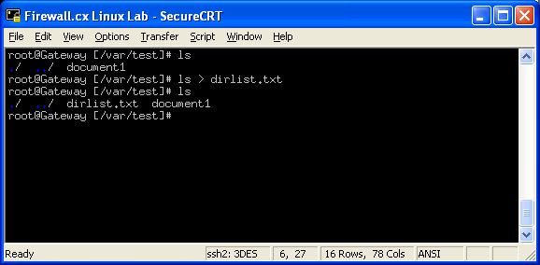
As you can see, we've taken the output of 'ls' and redirected it to our file. Let's now take a look and see what has actually been stored in there by using the command cat dirlist.txt :
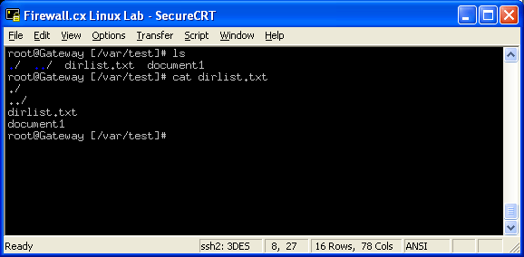
As expected, the dirlist.txt file contains the output of our previous command. So you might ask yourself 'what if I need to append the results?' - No problem here, as we've already got you covered.
When there's a need for appending files or results, as in DOS we simply use the double >> operator. By using the command it will append the new output to the file we have specified in the command line:
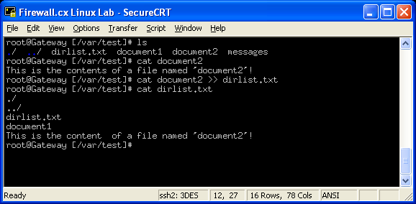
The above example clearly shows the content of our file named 'document2' which is then appended to the previously created file 'dirlist.txt'. With the use of the 'cat' command, we are able to examine its contents and make sure the new data has been appended.
Note:
By default, the single > will overwrite the file if it exists, so if you give the ls > dirlist.txt command again, it will overwrite the first dirlist.txt. However, if you specify >> it will add the new output below the previous output in the file. This is known as output redirection.
In Windows and DOS you can only run one command at a time, however, in Linux you can run many commands simultaneously. For example, let's say we want to see the directory list, then delete all files ending with .txt, then see the directory list again.
This is possible in Linux using one statement as follows : ls -l; rm -f *.txt; ls -l . Basically you separate each command using a semicolon, ';'. Linux then runs all three commands one after the other. This is also known as command chaining.

